SECTION 1: INTRODUCTION

INTRODUCTION

Urban-Econ: Development Economists was appointed by the Makhado Local Municipality in reaction to a request for the formulation of a Local Economic Development Study (LED) in order to address the challenges of poverty and development in the area. Makhado Municipality furthermore face a unique problem in that the Municipal area jurisdiction is large and is characterised by a mix of urban and rural economies, thus ranging from relatively strong economic performance to relatively isolated rural settlements with high levels of poverty. In keeping with the Constitution and the White Paper on Local Government, the onus for social economic development, as well as job creation rests on local government. In this regard the Makhado Local Municipality therefore strives to promote these issues in order to create an environment, which is conducive to economic development and which will attract investment.

PURPOSE OF THIS STUDY

The purpose of this study is to investigate the options and opportunities available to broaden the local economic base of the area in order to address the creation of employment opportunities and the resultant spin-off effects throughout the local economy.

The LED study forms part of the Integrated Development Plan (IDP) process and is one of the stepping stones toward achieving local economic development within the Makhado area.

It is imperative that actions should be taken to diversify the local economy from its dependency on resource activities towards production in the secondary and tertiary sectors. An important development principle underlying economic development is the broadening of the local economic base. This includes the introduction of new activities in the area (e.g. introducing the growth of drought tolerant crops), exploiting latent mineral resources identifies through beneficiation and the consequent establishment of small, medium and micro enterprises (SMMEs).

Apart from the above-mentioned actions, the Makhado Municipality LED will strive to address the following objectives and principles:

- To Broaden the current economic base (GVA Contribution)
- Promote Human Resource Development
- Promote Small Business Development (existing hives, one stop centres)
- Encourage Sustainable Employment Creation
- Retain existing businesses and Attract new Businesses (existing incentives, growth of businesses)
- Create intra-regional linkages
- Create an enabling institutional environment
- Promote Infrastructure Investment and Service Delivery
- Promote the local resources of the area (labour, minerals, production factors)
- Taking cognisance of development and planning in municipal context, i.e. adhering to a broader process.
- Utilisation of state-of-the-art technology to facilitate an in-depth analysis of the real (but latent) development opportunities in the key economic sectors in the study area.
- Identify practical sectoral programmes that could be used as basis for pro-active economic development initiatives.
- Undertake market research to identify micro-level business opportunities
- Augment the technical with in-depth interviews with experts in the appropriate fields in order to align with the most recent trends in the targeted sectors
- Identify financing sources and investment options that could enhance practical implementation
- Emphasise local job creation, alleviation of poverty and redistribution of opportunities and wealth
- Focus explicitly on opportunities for SMME development in all economic sectors
- Packaging of economic data in an electronic database to be utilised as investment marketing tool
- Ensure that the proposed strategies comply with acceptable environmental requirements
- Ensure that the development opportunities have a definite geographic and spatial orientation to provide guidance in terms of sustainable future spatial development planning
- Achieve skills transfer as part of the interaction with the client by utilising known approaches such as counterpart training
- Ensure that the strategy aligns with and add value to the existing policies and strategies such as the IDP

These principles and concepts will be applied to the study to ensure that facilitation functions can be approached in a proactive and dynamic manner.

METHODOLOGY

The following approach in Figure 1.1 will be employed in developing an Economic Strategy for the Makhado Municipal area. It clearly defines each step and actions to be taken during the execution of the study.

Figure 1.1: Methodology

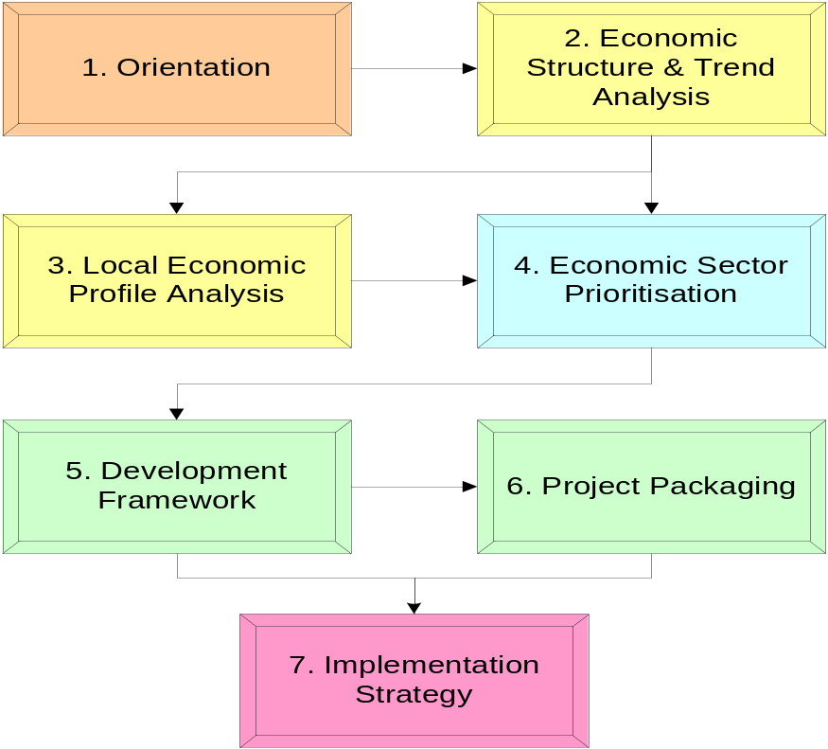

STEP ONE: ORIENTATION

The Study Area orientation included the assessment and analysis of a number of actions, which addressed:

- Finalisation of the project brief in terms of the goal and objectives
- Composition of the Inception Report
- Study of the existing information base
- Agreement on the final and interim deliverables
- Profiling of the various economic sectors
- Socio-economic characteristics of the area

STEP TWO: ECONOMIC STRUCTURE AND TREND ANALYSIS

This step dealt with the undertaking of an economic and socio-economic evaluation of the larger region with a view to compile a development perspective and identifies trends. A detailed analysis of trends, growth rates, potential for development, SMMEs, issues, problems, etc. formed the basis of this step.

STEP THREE: LOCAL ECONOMIC PROFILE ANALYSIS

This step dealt with the undertaking of primary data gathering exercises to be able to be in a position to provide a quantitative profile of the economic activities in Makhado Municipality. The local profile was compiled which was based on the results of the economic scan and skills scoping exercise.

STEP FOUR: ECONOMIC SECTOR PRIORITISATION

This step dealt with the identification of lead sectors, key issues and development opportunities. This was done by means of a focussed sectoral analysis and was verified by a prioritisation workshop. The sectoral potential analysis identified the sectoral comparative advantages of the economy and the development potential.

STEP FIVE: DEVELOPMENT FRAMEWORK

The purpose of this step was to formulate a strategy framework with key programmes based on the lead sectors and opportunities identified in the preceding steps. To be in a position to compile a local economic development strategy that can make a definite impact in terms of sustainable economic development, it was envisaged to identify realistic and practical projects for the sectoral programmes.

STEP SIX: PROJECT PACKAGING

This step aimed at packaging and funding selected anchor projects as business plans and evaluating potential funding sources. The objective of the business plans is to enable financial assistance by Government or financial institutions or to attract private investors in order to develop projects within the study area. It was envisaged that a total of four projects be selected in close consultation with the client and key stakeholders. These projects are regarded as pilot projects.

STEP SEVEN: IMPLEMENTATION STRATEGY

The purpose of this step was to integrate the different projects into a coherent regeneration strategy consisting of functional programmes. This was necessary to determine priorities for implementation phasing, budgeting and resource allocation. The identified projects, programmes and strategies are aligned with the Provincial PGDS as well as the IDP to ensure the incorporation of the LED initiatives in the Local Municipal budget.

LOCATION OF THE STUDY AREA

The study area is located in the northern corner of the Limpopo Province (see Map 1.1) where it borders with Botswana (to the north west) and Zimbabwe (to the north).

The Limpopo Province consists of six District Municipalities, namely:

- Vhembe District Municipality (DM)
- Waterberg District Municipality (DM)
- Capricorn District Municipality (DM)
- Mopani District Municipality (DM)
- Bohlabela District Municipality (DM)
- Sekhukhune District Municipality (DM)

Map 1.1: Makhado in Provincial Context
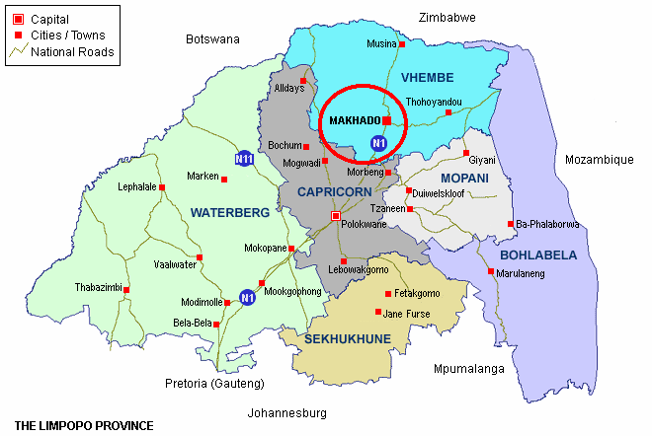

Each of the above-mentioned mentioned District Municipalities consist out of Local Municipalities. Makhado Municipality falls under the jurisdiction of Vhembe District Municipality. The Vhembe District Municipality consists out of the following Local Municipalities (refer to Map 1.2):

- Makhado Local Municipality (LM)
- Musina Local Municipality (LM)
- Mutale Local Municipality (LM)
- Thulamela Local Municipality (LM)

Makhado Municipality’s jurisdiction is divided into four distinct regions, namely (Refer to Map 1.3):

- Vuwani
- Dzanani
- Waterval
- Makhado

Most of the Makhado region can be classified as rural with small-scale agriculture and subsistence farming. The study area is heavily reliant on economic activities outside of its boundaries for employment opportunities and consumer products and services. The socio-economic conditions of people in the study area are also relatively poor when compared to those in surrounding areas.

Although a range of municipal and other services (infrastructure, schools, clinics, social services, etc.) are available in the Study Area, there is a general lack of sufficient facilities such as professional services, commercial and industrial services that could employ significant numbers of people and provide acceptable range, prices and quality to ensure that capital is generated locally.

Map 1.2: Local Municipalities of Vhembe District Municipality
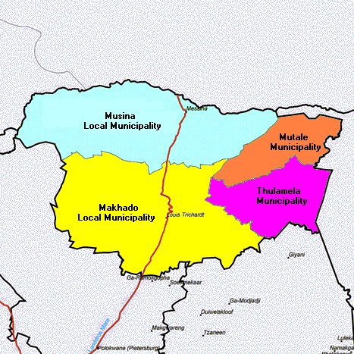
Source: Municipal Demarcation Board, 2005
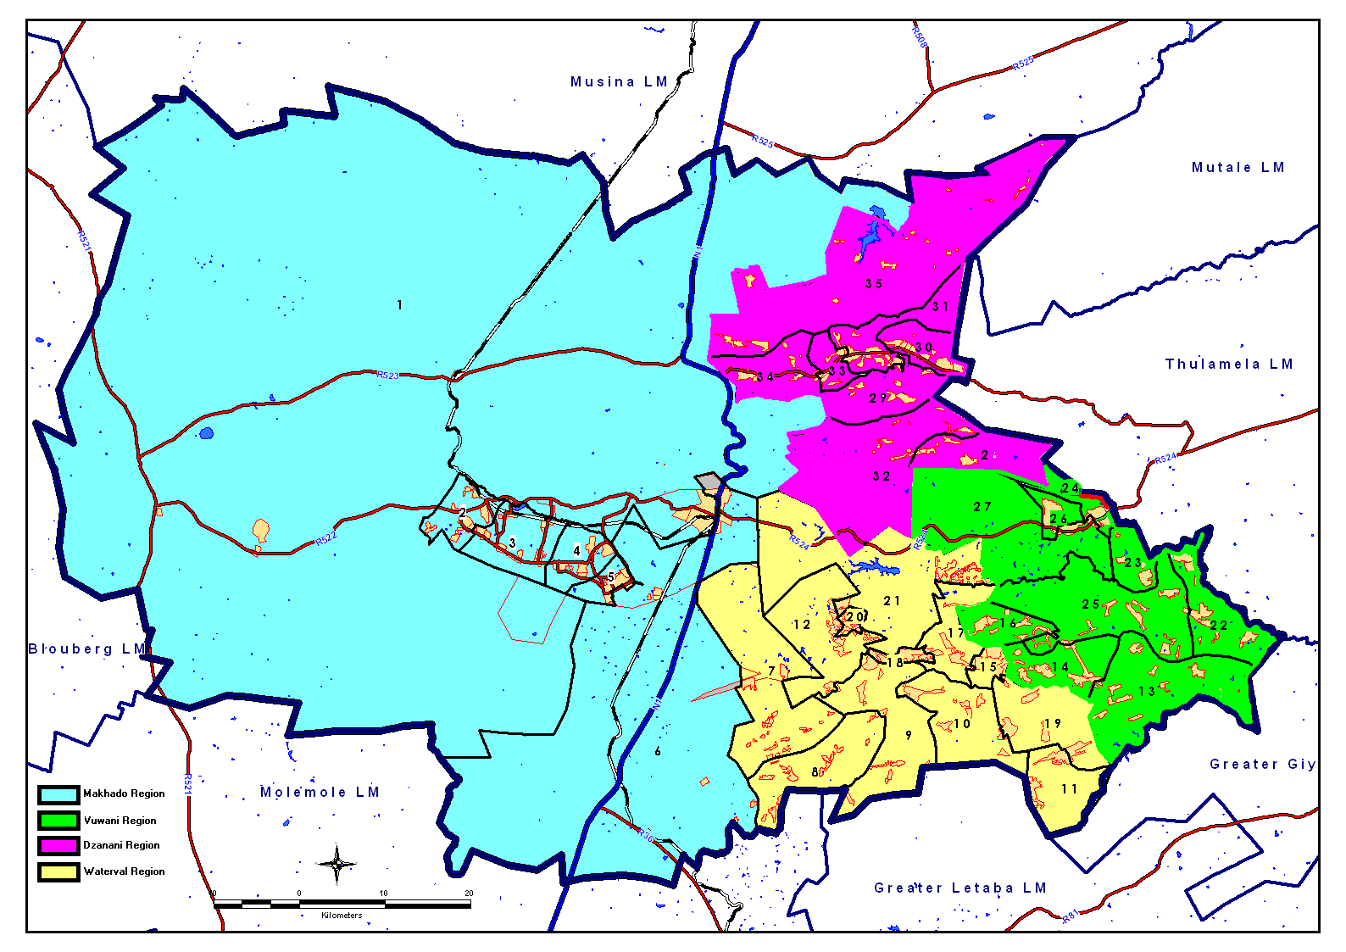
Map1.3: Regions of Makhado
The preliminary economic analysis that was conducted in the Inception Report indicated that Unemployment in the Study Area is very high while the agriculture and government sectors are the main employers in the local economy. It was also highlighted that the labour force is relatively unskilled and poorly educated, while many of the employment opportunities are found outside of the Study Area.

STRUCTURE OF THE REPORT

The remaining structure of the report includes, inter alia, the following sections:

Section Two: Introduction to LED

This step involves the collection of the existing documentation and previous studies done in the area, such as IDP, the local LED, etc. Additionally, the specific scope of the study as well as the communication channels between Urban-Econ and the Client was clarified. This section also discussed the concept of Local Economic Development and provided formal definitions, key concepts, provided an overview of LED Strategies as well as the LED Process

Section Three: Legal Framework

Local government is legally mandated in terms of the National Constitution (Act no. 108 of 1996) to “promote social and economic development”. This mandate marks a significant departure from the service-orientated focus of local government and has led to a series of important legal developments. The current legislative framework affecting local government (with reference to LED) is discussed in this section.

Section Four: Socio-Economic Profile

During this step, a socio-economic evaluation of the region and local area was performed. The key emphasis of this step is to compile a development perspective and identify trends. Secondary data sources were mostly used as base data for the analysis. This analysis provided critical basic information required for economic development planning, since it provides an indication of the socio-economic structure and functional specialization and other dynamic characteristics of the study area.

Section Five: Economic Profile

During this step, an economic evaluation of the region and local area was performed. The key emphasis of this step is to compile a development perspective and identify trends of the local economy. Secondary data sources were mostly used as base data for the analysis. This analysis provided critical basic information required for economic development planning, since it provides an indication of the economic structure and functional specialization and other dynamic characteristics of the study area.

Section Six: Sectoral Opportunity Analysis – Business Audit

During this step, key issues are analysed in terms of development opportunities and lead sectors in a manner that is consistent with a focused sectoral analysis.

Section Seven: Development Framework

The primary actions of formulating a strategic framework, with key programmes based on the lead sectors and opportunities identified in the preceding steps, will be undertaken in this step. The actions associated with this step include:

- Strategic visioning
- Sectoral programming

Section Eight: Strategic Plan

This phase involved integrating the different projects into a coherent regeneration strategy consisting of functional programmes. This is necessary to determine priorities for implementation phasing, budgeting and resource allocation

Section Nine: Project Identification

The results from the preceding sections are presented in a project inventory that contains a predetermined format with specific criteria.

Section Ten: Implementation Guidelines

This phase involves integrating the different projects into a coherent regeneration strategy consisting of functional programmes. This is necessary to determine priorities for implementation phasing, budgeting and resource allocation.

